**Setting up the Mobile App Development Environment along with an emulator**

1



TOOLS

There are **four tools** that you will need and they are available on the Internet for **free**:

* **Java JDK5 or JDK6**
* **Android SDK**
* **Eclipse IDE for Java Developers (optional)**
* **Android Development Tools (ADT) Eclipse Plugin (optional)**

 

Step 1: **Setup** Java **Development** Kit (JDK) You can download the JDK and install it, which is pretty easy. ...

Step 2: Configure **Android** SDK. ...

Step 3: **Setup** Eclipse **IDE**. ...

Step 4: **Setup Android Development** Tools (ADT) Plugin. ...

Step 5: Create **Android** Virtual Device. ...

8 comments.



**Step-by-step guide to Android development with Eclipse**

## Step 1: Setup Java Development Kit (JDK)

* You can download the JDK and install it, which is pretty easy. After that, you just have to set PATH and JAVA_HOME variables to the folder where you have **java** and **javac.**
* **Note for Windows Users:** If you installed the JDK in C:\jdk1.6.0_15 then you will have to add the following two lines in your C:\autoexec.bat file.
* Set PATH=C:\jdk1.6.0_15\bin;%PATH%

set JAVA_HOME=C:\jdk1.6.0_15

## Step 2: Configure Android SDK

* After you have successfully installed the Android SDK, it is time to configure it. After installing the Android SDK, you will get a window like this:

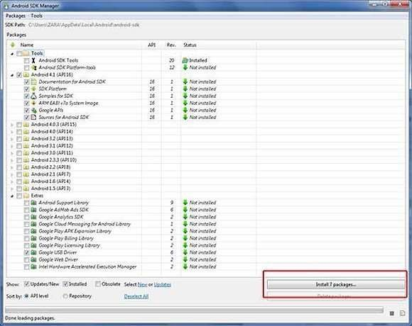

7/18/2019 Composing Mobile APPS Prabhu.C - 9

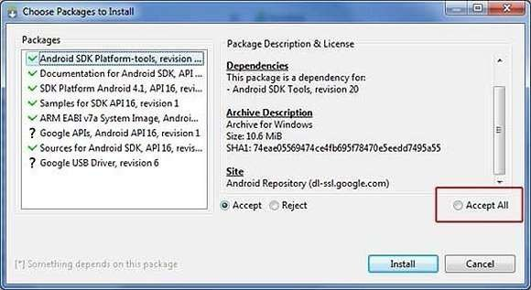Just de-select the Documentation for Android SDK and Samples for SDK packages if you want to reduce the installation size and time. Click on Install 7 packages to continue with the installation. You will get a dialogue box like this:

It will take some time to install, so in the meanwhile you could do some other task to kill the time. How long will it take? Well, it depends on the speed of your Internet connection. Once it is done, you can close the SDK manager.

**Step 3: Setup Eclipse IDE**

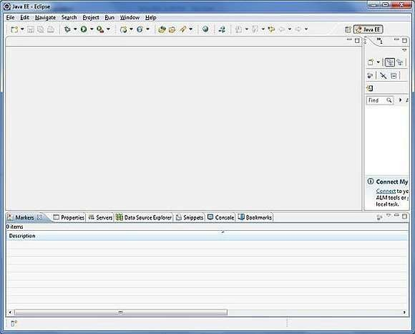Install the latest version of Eclipse. After successful installation, it should display a window like this:

**Step 4: Setup Android Development Tools(ADT) Plugin**

* + 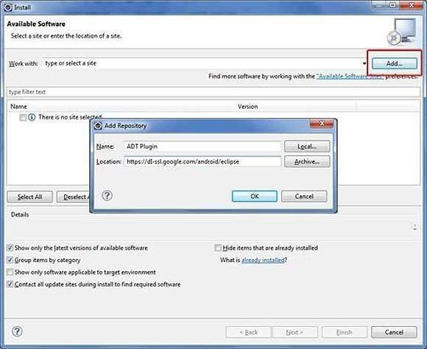Here you will learn to install the Android Development Tool plugin for Eclipse. To do this, you have to click on **Help > Software Updates > Install New Software**. This will display the following dialogue box.

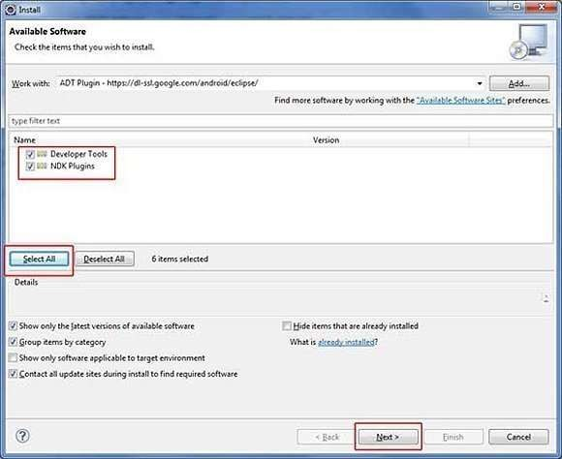Just click on the Add button as shown in the picture and add **https://dl- ssl.google.com/android/eclipse/** as the location. When you press OK, Eclipse will start to search for the required plug-in and finally it will list the found plug- ins.

# Step 5: Create Android Virtual Device

The last step is to create **Android Virtual Device**, which you will use to test your Android applications. To do this, open Eclipse and Launch Android AVD Manager from options **Window > AVD Manager** and click on **New** which will create a

|  |  |  |  |
| --- | --- | --- | --- |
| successful | Android | Virtual | Device. Use the |
| screenshot | below to | enter | the correct values. |

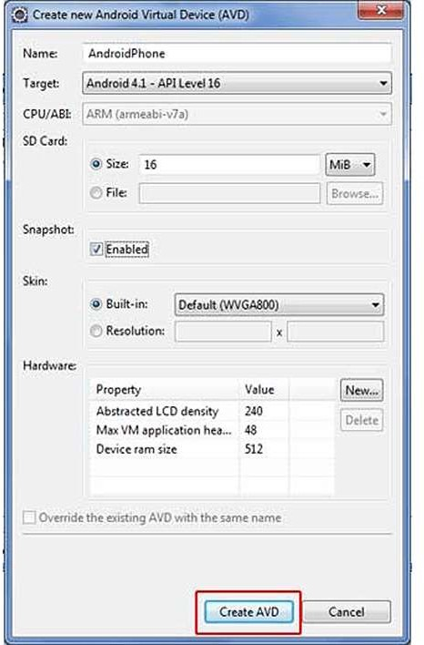

* Before we write the code, you need to know how to take input from the user. The most efficient way of taking input from the user is to use the Scanner class, which is found in the java.io package as it is just a two-step process.
* Scanner scanner = new Scanner(System.in); String input = scanner.next();

/* or String input = (new Scanner(System.in)).next(); */

I recommend using the Scanner class because it works equally well on command line as well as with Eclipse that we will use to make the Rock Paper Scissors app.